Preparing Your Handheld Devices with SurveyPocket
This document prepares your devices for mobile data collection using the SurveyPocket app. The SurveyPocket app requires a TCEC provided SurveyAnalytics.com account to create and assign surveys to a handheld device. Keep in mind that completing this process requires reliable Wi-Fi access. Also, steps on pages 1 & 4 must be completed on each device, and steps on page 2 - 3 are easier when completed on a computer, but can still be done in a web browser on a mobile device.

For more information, see our resources at http://tobaccoeval.ucdavis.edu/retail_campaign.php or watch the setup video at http://tobaccoeval.ucdavis.edu/files/ReadyTalk/getting_started/lib/playback.html

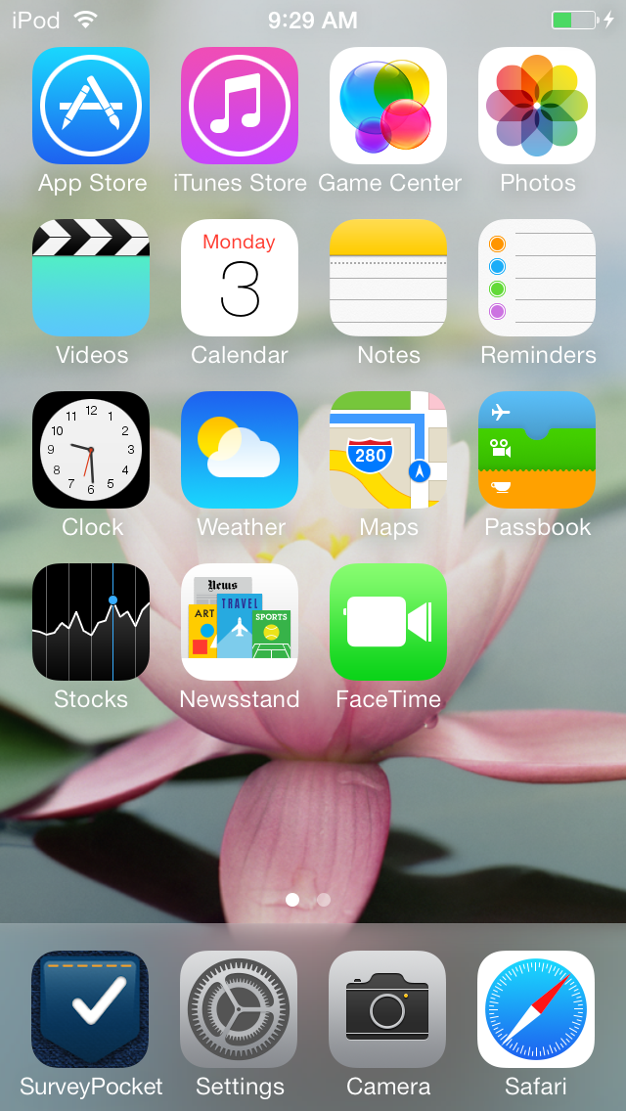
Download the SurveyPocket app on each device:

To get started on an Apple device:
- Go to the App Store
- Find and select the “Search” box, and type in “SurveyPocket”
- Select “ ” or the “ ” button
- Select “”
- If prompted, enter your Apple ID and password wait for the app to download

To get started on an Android device:
- Go to the Google Play Store
- Search for “SurveyPocket”
- Select “INSTALL”
- Enter your google ID if prompted
Image of the Google Play Store for Android devices
- If prompted, enter your Google account information, then wait for the app to download.
Add a new device key in your SurveyAnalytics.com account

Once the SurveyPocket app has been installed on your device, switch to a web browser on a desktop or your device to connect it to your SurveyAnalytics.com account. (Contact TCEC for your agency’s SurveyAnalytics.com account information.) You need a SurveyAnalytics.com account from TCEC to create your surveys and assign them to your device(s).

To add a new device, log into your Survey Analytics account, at www.SurveyAnalytics.com, then:

- Go to the Mobile tab, located near the top of the screen
- Select “Add Device Key” located near the bottom right
- Then a pop up window will appear (pictured on next page) where you select the device settings. The list below is the recommended settings for most purposes. However, depending on your particular data collection project, you may want to choose different settings. You can also change any of these options at a later time.

NAME: Feel free to use your own naming convention. At TCEC, we recommend using your
agencies initials followed by a number example TCEC001, TCEC002, and so on.

FOLDER: This is how you grant or restrict access to your surveys. Indicate which folder
you want this device to access. By default it is set to access all of the folders.

DEVICE EMAIL: You can enter your own email address or just leave this blank.

THEME: Your choice. TCEC selects IOS, because it’s easier to read.

BACKGROUND COLOR: Your choice. TCEC does not change the background color.

FONT COLOR: Your choice. TCEC does not change the font color. Just be aware that some
colors can be distracting or hard to read.
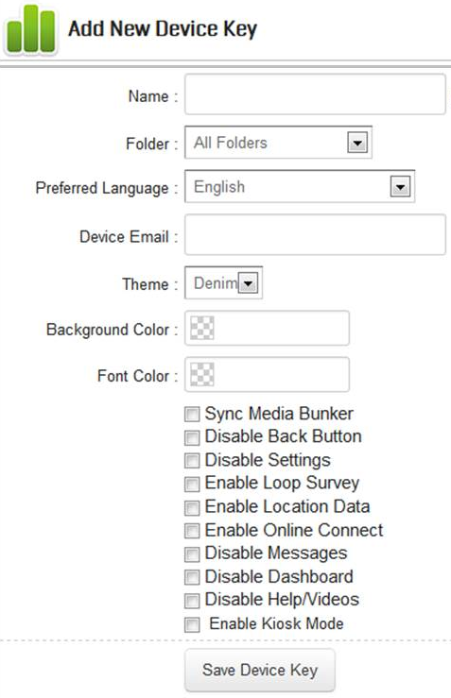
SUGGESTED OPTION CHECK BOXES:

For ease and speed, these boxes can all be left blank. You can also go back and edit device key settings later. Here are some suggested settings for most uses:

- Sync Media Bunker: do NOT check
Not used at this time

- Disable Back Button: do NOT check
You want the back button enabled so that survey respondents can go back to a previous question to change a response so that data are accurate

- Disable Settings: Your choice
This will stop users from accessing the Settings control in SurveyPocket. It is useful in preventing untrained users from changing the app settings. Alternatively, you can train data collectors not to change the settings

- Enable Loop Survey: do NOT check
Not used at this time

- Enable Location Data: do NOT check
(may be able to use in the future, but for now, do NOT check). This slows down the app and sometimes causes it to freeze

- Enable Online Connect: do NOT check
This will automatically submit the survey that is taken as soon as it is completed. It is dependent on the device(s) having a consistent Internet connection, so if there’s no connection, it slows down the app and sometimes causes it to freeze

- Disable Messages: Your choice (available in a future release)
The Messages tab will not be visible in the SurveyPocket app on Apple devices

- Disable Dashboard: CHECK (available in a future release)
The Dashboard tab will not be visible in the SurveyPocket app on Apple devices

- Disable Help/Videos: do NOT check
The Help/Videos tab contains helpful how-to videos and can be accessed even without Internet connectivity

- Enable Kiosk Mode: do NOT check
Not used at this time
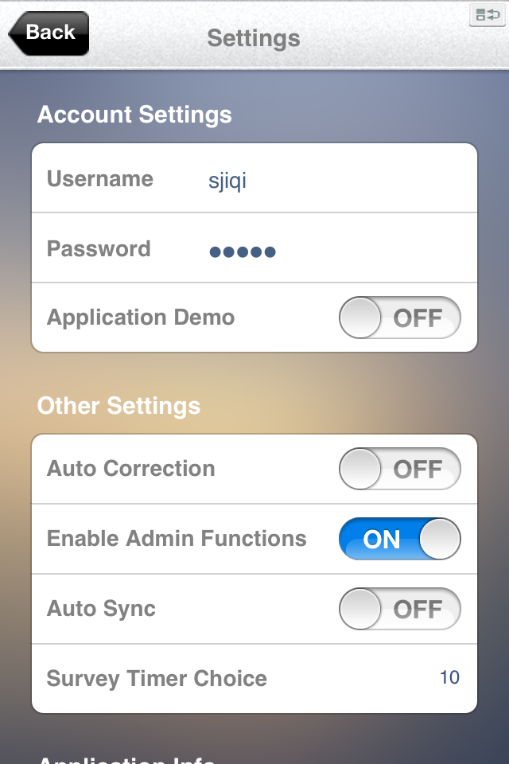
- Select “Save Device Key.” Then SurveyAnalytics.com will create a unique “Username/Key” and “Password” combination that needs to be entered into a mobile device. (Don’t worry, you only enter it once, so there’s no need to memorize it!)
Connect your device to your SurveyAnalytics.com account
Next, switch back to your Wi-Fi connected mobile device and open the SurveyPocket app. The “Settings” screen will appear (pictured right)
- Turn off “Application Demo” by sliding the button left
- Type in the “Username/Key” from the SurveyAnalytics.com page you just created
- Type in the matching “Password” from the SurveyAnalytics.com page you just created
- Ensure “SurveyAnalytics” appears in the “Sync Service” line.
- Enable Admin Functions by sliding the button right
A
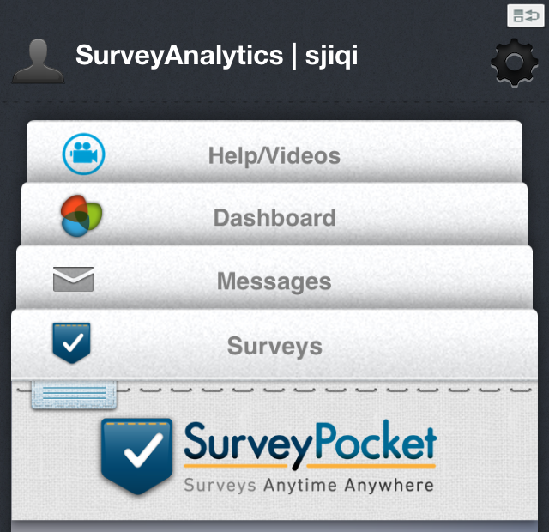
- Select the “ ” button at the TOP LEFT and your device should automatically “synch” to your account.
  - Your device is synched when you see screen A (right). To view the surveys on the device, touch and hold the “Surveys” tab then drag it up.
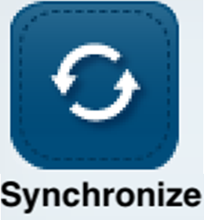
  - If, instead, you see screen B, (below) select the gear
on the BOTTOM RIGHT. Then select
B
B
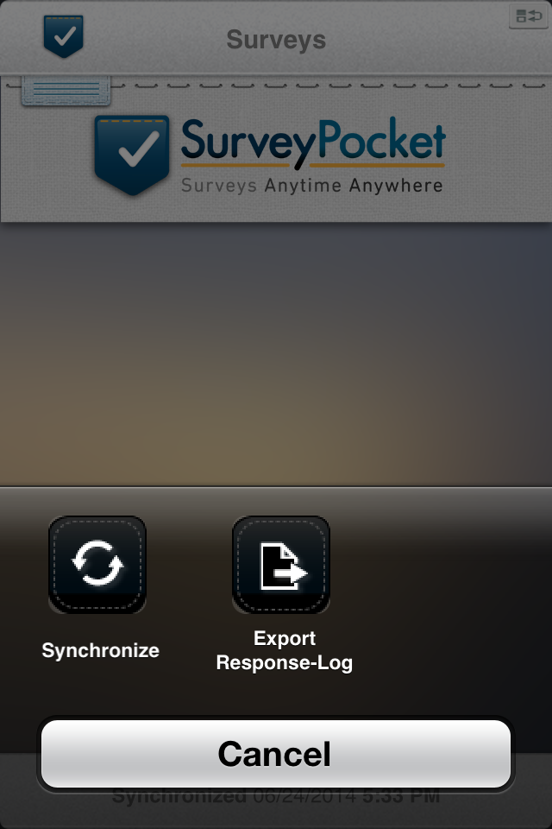
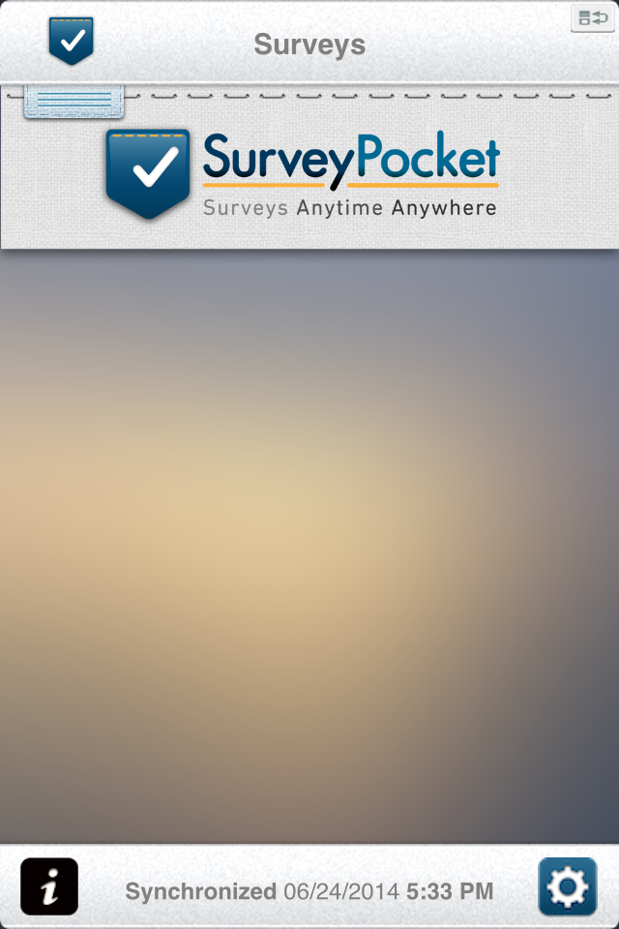
Note: You will need to repeat ALL of these steps for each device you will be using.

For technical assistance related to handheld devices, contact the TCEC Data Collection Help Desk at 530-754-8929 or JTAnd@phs.ucdavis.edu

