Synching your Mobile Devices

With your TCEC issued SurveyAnalytics.com account and devices loaded with the SurveyPocket app, you can collect data anytime and anywhere, even without an Internet connection. However, this requires communication between your devices and your SurveyAnlytics.com account. The way in which these two systems communicate is through a process called “Synchronize.”

You’ll want to synchronize or synch your devices each time you:
- create or edit surveys
- edit folder content or permissions
- add devices or change device permissions
- complete a day of data collection on your mobile devices
- are unsure if the surveys on your mobile devices are up to date with your surveys in SurveyAnalytics.com

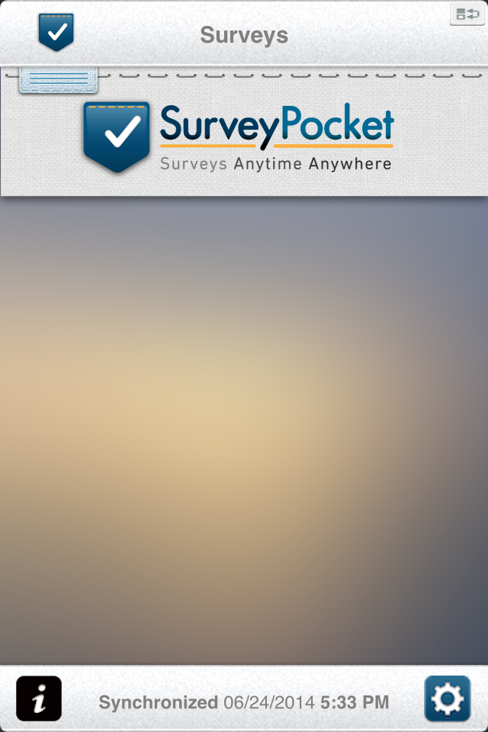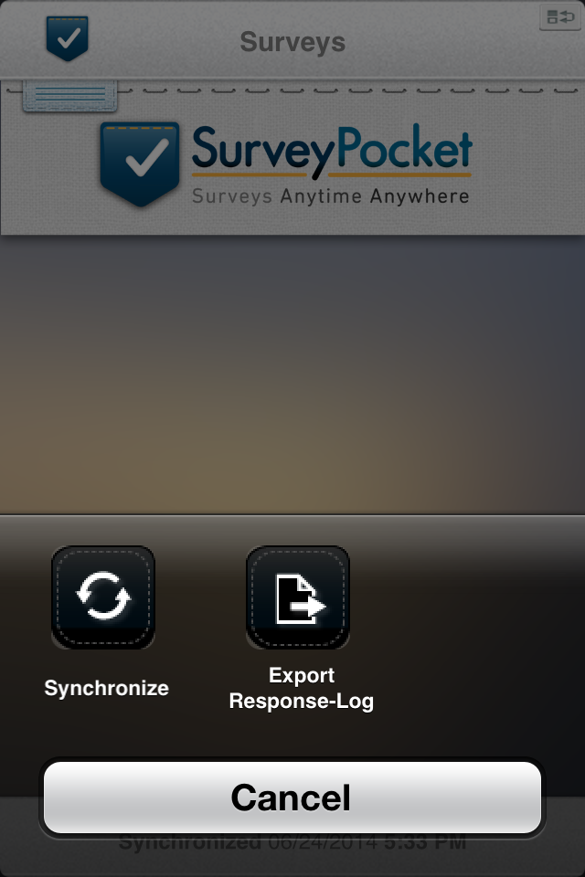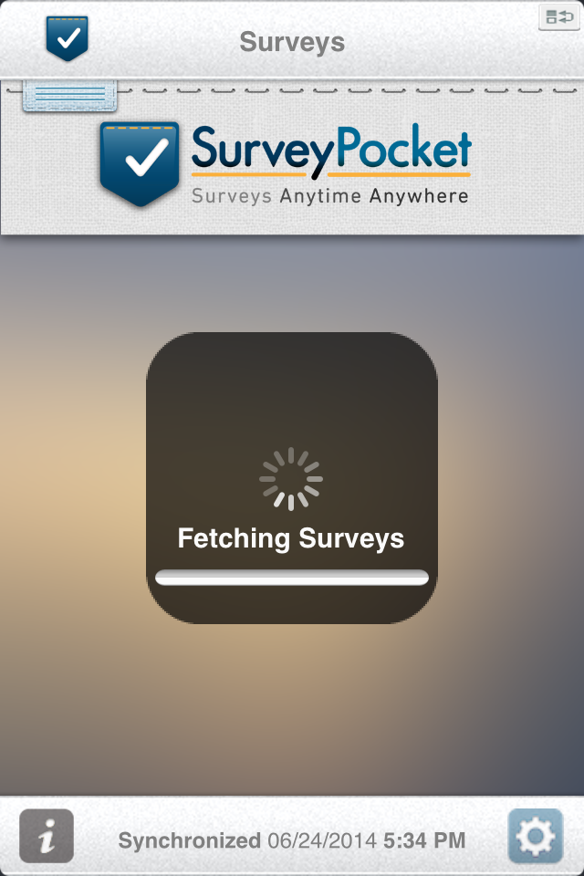

To synch devices, first ensure that it is connected to Wi-Fi. Then follow these steps:
- Open the SurveyPocket app
- Select the gear symbol on the LOWER RIGHT side of the “Surveys” tab
- Then select “Synchronize”
- After a few seconds, the device will be synchronized with your SurveyAnalytics.com account, and you should see any changes you’ve made.
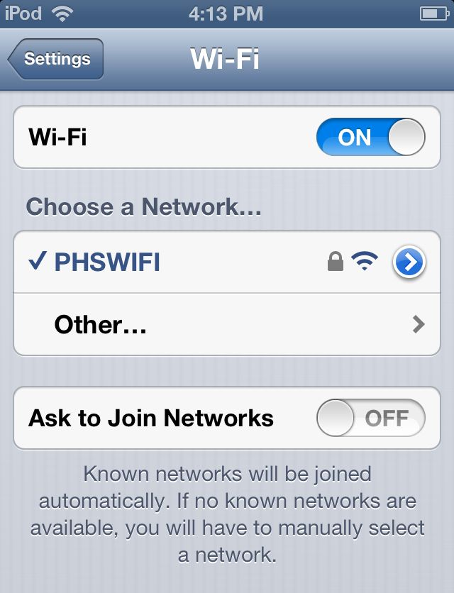
Troubleshooting

If an error message pops up on the device while attempting to synch, double check to make sure your device is connected to Wi-Fi. Some Wi-Fi connections require an extra step where you accept terms and conditions and/or log in.

To ensure if you have Wi-Fi connection you can:

- ensure that the Wi-Fi symbol appears at the top left of the screen
- go to settings and make sure there’s a check next to a Wi-Fi network
- open Safari and navigate to a website

Otherwise, you can always try closing the SurveyPocket app and then re-opening it or turning off the device and then turning it back on. If you still have problems, contact the TCEC Help Desk.

For technical assistance related to handheld devices, contact the
TCEC Data Collection Help Desk at 530-754-8929 or JTAnd@phs.ucdavis.edu

