`

Incomplete Surveys.

With SurveyPocket version 5.9 or higher users have the ability to finish an incomplete survey while in the field. This process allows a data collector to exit out of a survey and completing it at a later time. This process may not work if a survey crashes, it will only work if a survey is interrupted manually by a data collector by either pressing the device home button, or by selecting the SurveyPocket app home button. To continue working on an incomplete survey follow these steps:

- Log on to SurveyAnalytics.com using your web browser
- Select the Mobile tab
- Select the device key or device keys you wish to alter
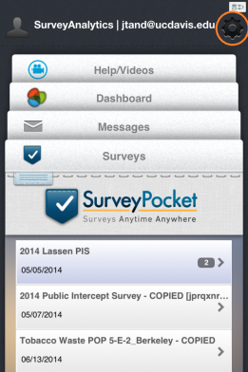
- Confirm that “Disable Settings” is UNCHECKED
- Select “Save Device Key” at the bottom of the page scrolling the page down
Use your Mobile Device(s) for the following steps:
- Confirm that the device is on an active Wi-Fi network
- Open the SurveyPocket app
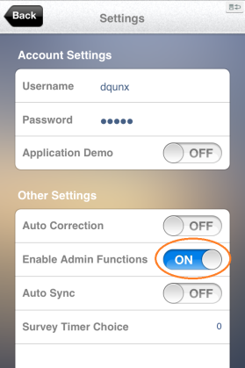
- Synch the device
- Select app settings
- Scroll the settings page down and turn on “Enable Admin Functions”
- Select “Back” at the top left of the page
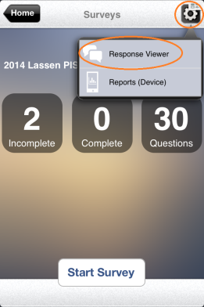
Duplicate these steps on every device you plan to use on the field
To complete an interrupted survey follow these steps:
- Select the gear Icon from the Survey Launch page
- Select “Response Viewer” from the pop up menu
- Select the survey to be completed
- Complete the survey

NOTES:
- Only incomplete surveys will be available for editing
  - Once a survey is completed it cannot be edited on the SurveyPocket app
- Will not work on surveys that have crashed
- Will only work if the administrative steps are taken
- MUST BE COMPLETED PRIOR TO SYNCH
- Should only be used as a last resort

